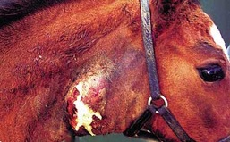

**Organ:** skin

**Lesion:** Lymphadenitis and lymphangitis that has ulcerated to this horse's skin.

**Etiology:** *Burkholderia mallei*

**Diagnosis:** Glanders (Farcy).

**Organ:** skin

**Lesion:** ruptured abscess draining white creamy pus.

**Etiology:** *Burkholderia mallei*

**Diagnosis:** Glanders

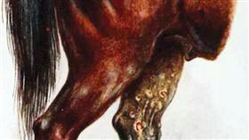

**Organ:**Human, skin.

**Lesion:** There is extensive ulceration and sloughing of the skin of the forearm and hand; the underlying tissues are edematous and hemorrhagic. Ulcers may be connected by lymphatic vessels (“Farcy pipes”) full of thick purulent exudate.

**Etiology:** *Burkholderia mallei*

**Diagnosis:** Glanders

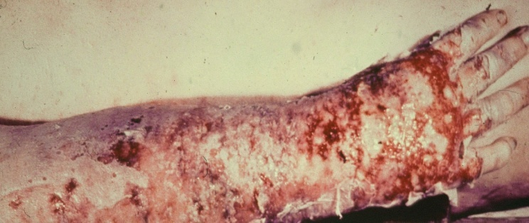

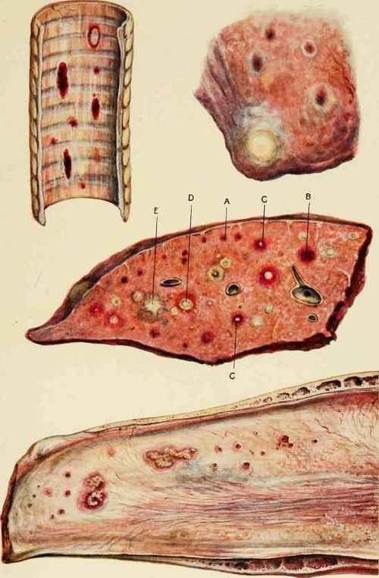

**Organs:** Trachea, Lung and Nasal septum.

**Lesion:**

1. [**Trachea**](http://chestofbooks.com/animals/horses/Health-Disease-Treatment-1/The-Trachea.html)**,** showing earliest stage of glanderous ulceration (hemorrage).

2, Portion of [**Lung**](http://chestofbooks.com/animals/horses/Health-Disease-Treatment-1/The-Lungs.html), showing superficial nodules of glanders.

3. Section of **Lung,** showing A, haemorrhagia or earliest perceptible stage of pulmonary glanders; B, extended haemorrhage; C, commencing caseation; D, cavity filled with caseous matter; E, fibroid degeneration of nodule.

4 Ulcerated Mucous Membrane of **Nasal Septum**.

**Etiology:** *Burkholderia mallei*

**Diagnosis:** Glanders

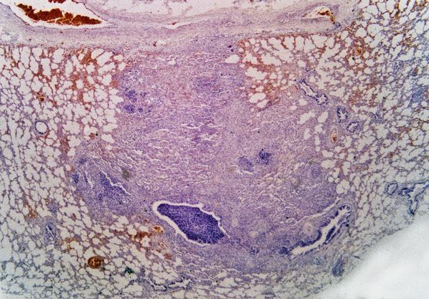

**Organ:** Lung

**Lesion:** Microscopic appearance showing suppurative broncho pneumonia with congestion and emphysema (H and E Stain)

**Etiology:** Burkholderia mallei (earlier Pseudomonas mallei)

**Diagnosis:** Glanders

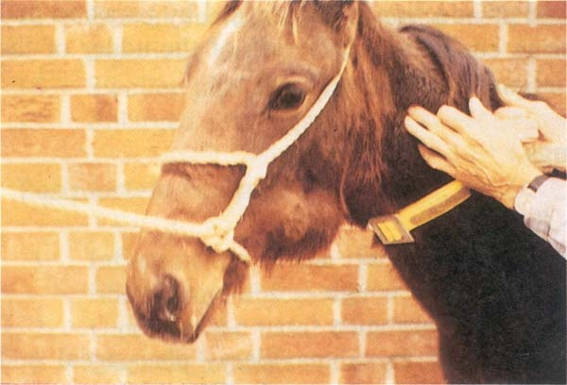

**Organ:** Equine mesenteric lymph node

**Lesion:** (A) enlargement of L.N due to abscess. (B)a cut in the same L.N showed white creamy purulent exudates.

**Etiology:** *Streptococcus equi*

### Diagnosis: Strangles

**Organ:** L.N.

**Lesion:** Hot painful abscesses of the lymph nodes of the throat.

**Etiology:** *Streptococcus equi*

### Diagnosis: Strangles (Distemper)

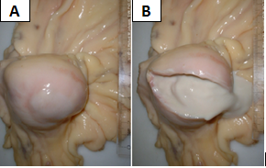

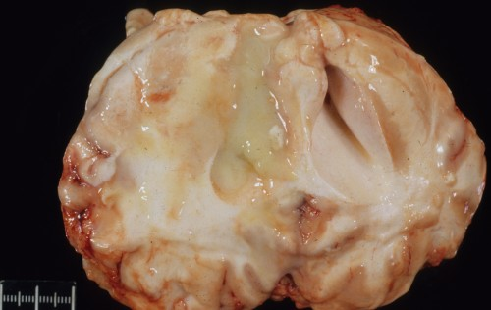

**Organ:** Brain

**Lesion:** Abscess in the brain, cross-sectional view.

**Etiology:** *Streptococcus equi*

### Diagnosis: Strangles (Distemper)

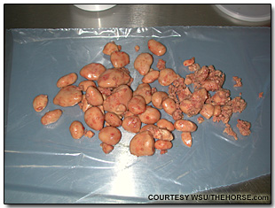

**Organ:** Solid masses from the guttural pouch

**Lesion:** Purulent discharge can thicken into masses known as chondroid. This collection was surgically removed from the guttural pouch of a horse with a chronic infection.

**Etiology:** *Streptococcus equi*

### Diagnosis: Strangles (Distemper)